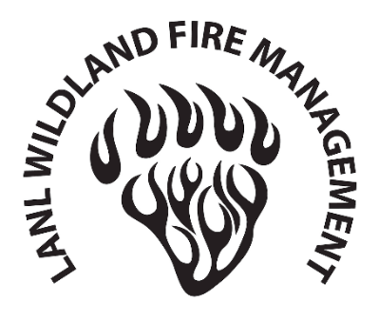 | Stage III Fire Restriction Exemption Request

ATTENTION: THIS FORM MUST BE CARRIED ON PERSON WHEN CONDUCTING WORK ACTIVITIES ASSOCIATED WITH THE EXEMPTION (IF APPROVED)

Request for Exemption to Complete Work Activity
Restricted (Check Box) | Prohibited (Check Box)
Smoking in all areas of the Laboratory except in designated smoking areas.  Performing work that is not considered a mission-essential activity in forested and/or undeveloped areas of LANL.  Driving on non-established roads | Use of explosives.  Discharging a firearm.  Access to recreational areas for walking, hiking, jogging, biking, and similar activities.
Notes:
- Emergency Response Officials performing official duties are exempt from the applicable fire restrictions.
- Personnel working at construction sites, trails, roads, and open areas, such as paved lots and improved areas around occupied structures, may only access those areas with an Associate-Director-approved integrated work document (IWD) that addresses wildland fire hazards.
- No notice inspections may be conducted by LANL Security and Emergency Operations Division, LANL Fire Protection Division and/or Protective Force to verify that activities and restrictions continue to be in enforced.
- Complete all information up to approvals and email your completed form to LANL Fire Protection Division at fpdostaff@lanl.gov.

Description of Work Activity
Requesting Organization:
Responsible Line Manager
Contact Phone Numbers
Date(s) and Time(s) Work will be Conducted (exemptions will not be approved for extended periods):
Work Location:
Scope of Work:
Approved IWD Number:
Identified Hazards:
Required Mitigation Activities (List all that apply)

Requester | Approval
Name Date  Title: & Organization: | Fire Protection Division Office Date

Instructions for requester completing the form

- Check all applicable checkboxes for Restricted and/or Prohibited activities for your work activity.
- Complete all text boxes within the Section titled “Description of Work Activity.”
- Enter the Name of the requesting manager and the date of the request in the text boxes on the line beneath the Requesting Manager Section. Include the requesting manager’s title and organization in the appropriate text boxes.
- Email the completed form to LANL Fire Protection Division at fpdostaff@lanl.gov. The LANL Fire Protection Division Office will make a determination to approve or deny the exemption. If the exemption is approved or denied the Fire Protection Division Office will send the form back to the requester signed or with a reason for denial.
Instructions for Fire Protection Division
- Review the exemption request form upon receipt and make a determination to approve or deny.
- If approved, sign the form and send it back to the requester and copy the Emergency Operations Support Center (EOSC) and the LANL Wildland Fire Program Staff at: 24seven@lanl.gov; jsievers@lanl.gov; mannyl@lanl.gov; jboyet@lanl.gov; and lancef@lanl.gov. The LANL Wildland Fire Program will retain the document on the Wildland Fire SharePoint Site.
- If denied, send the requester a written reason for the decision for denial.

